System and Software Architecture Description (SSAD)

Mission Science Information and Data Management System 3.0

Team 03

Fei Yu: Project Manager, Life Cycle Planner
Yinlin Zhou: Prototyper, Operational Concept Engineer
Yunpeng Chen: Requirements Engineer
Jingwen Peng: Builder, UML Modeler
Chenguang Liu: System Architect
Steven Lee: Requirements Engineer, IIV&V, Quality Focal Point

9 December 2013

Version History
Date | Author | Version | Changes made | Rationale
09/27/13 | CL | 2.0 | - Initial release | - Initial Team 03 draft of System Software Architecture Description
10/23/13 | SL | 2.1 | - Update content for grammar, spelling, and term consistency | - Final draft for DC package.
11/30/13 | CL | 3.0 | - Update the process diagram, System Context Diagram Artifacts and Information Diagram, User Grid  - Add Deployment diagram | - Draft for TRR package.
12/09/13 | CL | 3.1 | - Add Use Grid | - Final for TRR package.

Table of Contents

System and Software Architecture Description (SSAD) i
Version History ii
Table of Contents iii
Table of Tables iv
Table of Figures v
1. Introduction 1
1.1 Purpose of the SSAD 1
1.2 Status of the SSAD 1
2. System Analysis 2
2.1 System Analysis Overview 2
3. Technology-Independent Model 11
3.1 Design Overview 11
4. Architectural Styles, Patterns and Frameworks 13

Table of Tables
Table 1 Actors Summary 2
Table 2 Artifacts and Information Summary 4
Table 3 Process Description 5
Table 4 Typical Course Action 5
Table 5 Alternate Course of Action 5
Table 6 Process Description 6
Table 7 Typical Course of Action 6
Table 8 Process Description 6
Table 9 Typical Course of Action 7
Table 10 Exceptional Course of Action 7
Table 11 Process Description 7
Table 12 Typical Course of Action 7
Table 13 Alternate Course of Action 8
Table 14 Process Description 8
Table 15 Typical Course of Action 8
Table 16 Alternate Course of Action 8
Table 17 Process Description 9
Table 18 Typical Course of Action 9
Table 19 Alternate Course of Action 9
Table 20 Process Description 9
Table 21 Typical Course of Action 10
Table 22 Process Description 10
Table 23 Typical Course of Action 10
Table 24 Software Component Description 12

Table of Figures
Figure 1 System Context Diagram 2
Figure 2 Artifacts and Information Diagram 4
Figure 3 Process Diagram 5
Figure 4 Software Component Description 11
Figure 5 Deployment Diagram 12

Introduction

Purpose of the SSAD

The SSAD serves to document the architecture, and more specifically, the object-oriented analysis and design of the Mission Science 3.0 system. The SSAD is to be used by the builder in building the prescribed system. The system should remain faithful to the prescribed architecture of the SSAD, or the SSAD should be updated to match the latent architecture. The SSAD is used as reference by the maintainers once the system is delivered.

Status of the SSAD

The SSAD has also been revised to more accurately document the architecture of the system as more information has been discovered. The Artifact diagrams are much more accurate, and directly from the database system with two major views: Student and Project. Grammar has been revised. Use cases are clearer and more correct. General formatting is easier to read. The references to Administrator have been corrected to Coordinator for consistency.

System Analysis

System Analysis Overview
The primary aim of the Mission Science 3.0 Access Database is facilitate teaching STEM lessons to elementary children. This includes maintaining the system for Maintainer. It also includes managing STEM project, activity and Search functions for Administrator. Student worker could manage survey, sub activity, sign in sheet, reserve inventory and input results for survey.

System Context
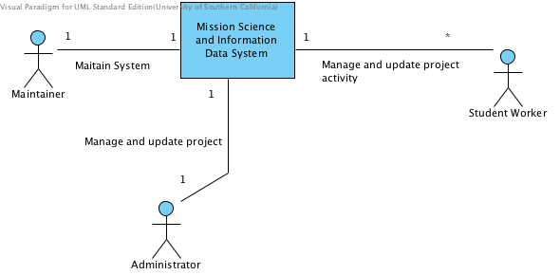
Figure 1 System Context Diagram
Table 1 Actors Summary
Actor | Description | Responsibilities
Administrator | Manager of the database system and coordinator of Mission Science efforts | - Manage STEM project  - Manage activity  - Search
Student Worker | Viterbi/USC graduate student visits the various STEM school locations to teach the specified lesson plan(s). | - Manage survey  - Manage sub activity  - Sign in sheet  - Reserve inventory  - Input results for survey
Maintainer | One of the team members will maintain the system | - Maintain the system

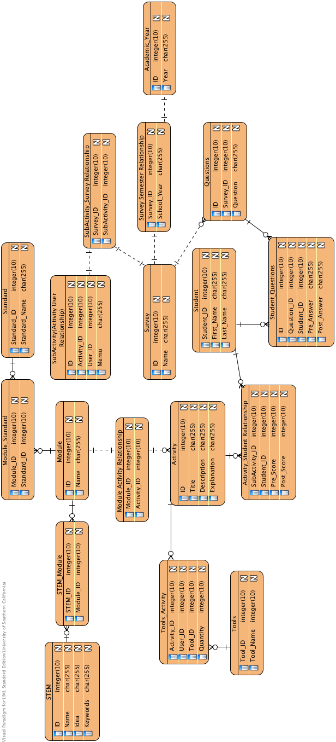
Artifacts & Information
Figure 2 Artifacts and Information Diagram
Table 2 Artifacts and Information Summary
Artifact | Purpose
Project | Project means new STEM project here. STEM means science, technology, engineering and mathematics.
Module | Each project includes several modules.
STEM_Module | The relationship table for STEM project and Module.
Standard | The standard that government formulated should be consistency with the STEM project.
Module_Standard | Relationship table for Module and Standard.
Activity | Each module includes sever Activities.
Module_Activity | Relationship table for Module and Activity.
Tools | All possible tools and materials that are documented.
Tools_Activity | Relationship table for Tools and Activity.
Student | The Student take all the projects.
Activity_Student | Relationship table for Activity and Student.
Questions | Relationship table of Questions and Survey.
Student Questions | This table includes all the answers of students.
Survey | The survey for each Sub activity.
SubActivity | Relationship table for Activity and User.
SubActivity_Survey | Relationship table for Module and Standard
AcademicYear | Students have information associated for each Academic Year.
Survey_AcademicYear | Relationship table for Module and Standard

Behavior
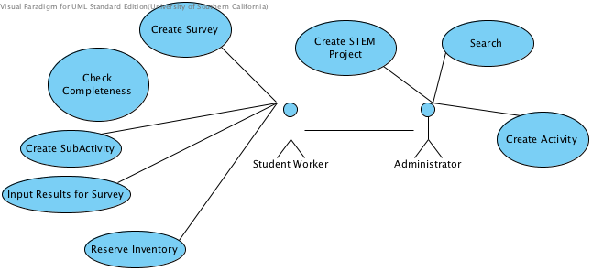

Figure 3 Process Diagram

Administrator Behavior

Create STEM Project
Table 3 Process Description
Identifier | UC-1: Create STEM Project
Purpose | Add and update information about STEM Project
Requirements | Administrator has designed the STEM Project
Development Risks | STEM project information may be incomplete
Pre-conditions | A particular project should not already be in the database.
Post-conditions | The particular project will be recorded in the database

Table 4 Typical Course Action
Seq# | Actor’s Action | System’s Response
1 | Input project name and main idea
2 | Choose a module or add a new module
3 | Choose a keyword or add a new keyword
4 | Click Create
5 |  | Show the message “Successfully Created”
Table 5 Alternate Course of Action
Seq# | Actor’s Action | System’s Response
1 | Input project name and main idea
2 | Choose a module or add a new module
3 | Choose a keyword or add a new keyword
4 | Click create
5 |  | Show the message “This project has been created.”
6 | Decide to change information, or not enter project

Create Activity
Table 6 Process Description
Identifier | UC-3: Create Activity
Purpose | Add and update information about activity
Requirements | The student worker designs an activity and knows which Project it belongs to.
Development Risks | Activity information may be incomplete
Pre-conditions | A particular activity should not already be in the database
Post-conditions | The particular activity will be recorded in the database

Table 7 Typical Course of Action
Seq# | Actor’s Action | System’s Response
1 | Input activity name
2 | Input description and explanation of this activity
3 | Select a module
4 | Select a standard and add it
5 | Select a national standard and add it
6 | Select a next standard and add it
7 | Click create
8 |  | Show the message “Successfully Created.”

Search
Table 8 Process Description
Identifier | UC-4: Search
Purpose | Search something special information by an item
Requirements | There exits the item the user want to Search
Development Risks | The particular item doesn’t exist or exists duplicate items.
Pre-conditions
Post-conditions | If the item is existed, show the search result.  If not, show no result is found

Table 9 Typical Course of Action
Seq# | Actor’s Action | System’s Response
1 | Input something need to be searched
2 | Choose the item searched by
3 | Click Search button
4 | Double click the item
5 |  | Show the search result
Table 10 Exceptional Course of Action
Seq# | Actor’s Action | System’s Response
1 | Input something need to be searched
2 | Choose the item searched by
3 | Click search button
4 |  | Show no search result is found
5 | Re-input something need to be searched

Student worker Behavior

Create SubActivity
Table 11 Process Description
Identifier | UC-3: Create SubActivity
Purpose | Add and update information about SubActivity
Requirements | The student worker designs a subactivity and knows which activity it belongs to.
Development Risks | SubActivity information may be incomplete.
Pre-conditions | A particular subactivity should not already be in the database.
Post-conditions | The particular subactivity will be recorded in the database.

Table 12 Typical Course of Action
Seq# | Actor’s Action | System’s Response
1 | Select a particular activity
2 | Select a user
3 | Input memo
4 | Select Tools and add them
5 | Input survey name
6 | Add questions
7 | Click create
8 |  | Show message “Successfully Created.”
Table 13 Alternate Course of Action
Seq# | Actor’s Action | System’s Response
1 | Select a particular activity
2 | Select a user
3 | Input memo
4 | Select Tools and add them
5 | Input survey name
6 | Add questions
7 | Click create
8 |  | Show message “This subactivity has been created.”
9 | Decide to change information, or not enter subactivity

Create Survey
Table 14 Process Description
Identifier | UC-2: Create Survey
Purpose | Add and update information about Survey
Requirements | The administrator has designed the Survey
Development Risks | Survey information may be incomplete
Pre-conditions | A particular survey should not already be in the database
Post-conditions | The particular survey will be recorded in the database

Table 15 Typical Course of Action
Seq# | Actor’s Action | System’s Response
1 | Input survey name
2 | Choose survey year
3 | Input questions
4 | Click create
5 |  | Show message “Successfully Created.”
Table 16 Alternate Course of Action
Seq# | Actor’s Action | System’s Response
1 | Input survey name
2 | Choose survey year
3 | Input questions
4 | Click create
5 |  | Show message “This survey has been created.”
6 | Decide to change information, or not enter survey

Input Results for Survey
Table 17 Process Description
Identifier | UC-7: Input Results for Survey
Purpose | Input students result of survey
Requirements | The student worker has designed the question
Development Risks
Pre-conditions | A particular survey result should not already be in the database
Post-conditions | The particular survey result will be recorded in the database

Table 18 Typical Course of Action
Seq# | Actor’s Action | System’s Response
1 | Input student name
2 | Choose survey year
3 | Click Search button
4 | Input result
5 |  | Show message “Successfully Input.”
Table 19 Alternate Course of Action
Seq# | Actor’s Action | System’s Response
1 | Input student name
2 | Choose survey year
3 | Click Search button
4 | Input result
5 |  | Show message “This survey result has been created.”
6 | Decide to change information, or not enter survey result

Sign In Sheet
Table 20 Process Description
Identifier | UC-5: Sign in sheet
Purpose | Check if the student complete this lesson
Requirements | The student, sub activity has been created in the database
Development Risks | No this sub activity in the database.
Pre-conditions | A particular student has not signed in a particular project
Post-conditions | A particular student has signed in a particular project

Table 21 Typical Course of Action
Seq# | Actor’s Action | System’s Response
1 | Input student name
2 | Select a semester year
3 | Click Get Student Button
4 | Select project name
5 | Select project date
6 | Select user name
7 | Check the student who took the lesson
8 |  | Show message “Successfully Input.”

Reserve Inventory
Table 22 Process Description
Identifier | UC-8: Reserve Inventory
Purpose | Reserve inventory
Requirements | The tools existed in the database
Development Risks | Reservation might be less than zero.
Pre-conditions | A particular tool should not be reserved.
Post-conditions | A particular tool will be reserved.

Table 23 Typical Course of Action
Seq# | Actor’s Action | System’s Response
1 | Input project name
2 | Input tools name
3 | Click Search button
4 | Double one item
5 | Input number need to be reserved
6 |  | Show message “Successfully Input.”

Technology-Independent Model

Design Overview

System Structure

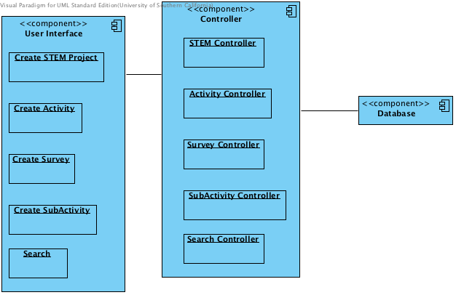
Figure 4 Software Component Description

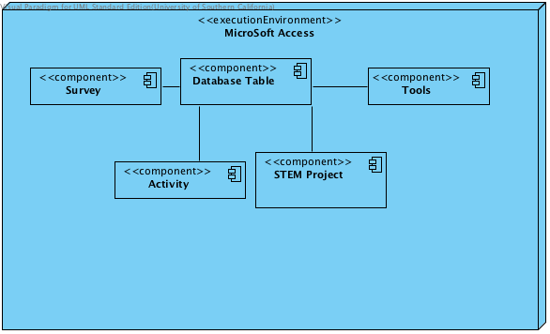
Figure 5 Deployment Diagram
Table 24 Software Component Description
Software Component | Description
User Interface | This item includes STEM project UI, Activity UI, Survey UI, Sub Activity UI and Search UI.
Controller | This item includes STEM Controller, Activity Controller, Survey Controller, Sub Activity Controller and Search Controller.
Database | This item stores all the data.

Architectural Styles, Patterns and Frameworks
Table 25 Architectural Styles, Patterns, and Frameworks
Name | Description | Benefits, Costs, and Limitations
Component- based | We separate the system into several components and each team member completes one components. | Benefits: concurrent programing will improve efficiency  Limitations: collision between different components and hard to merge

